24HOURS PROGRAMMABLE

ELECTRONIC TIMER SWITCH
- DIN-sized 35mm Rail Installation.
- Latest technology COMS quartz Mico-controller
- Digital electronic general purpose time switch with daily programs
- Minimum interval:15minutes; easy-to-use.
- Battery inside provides power if the out power is cut.
- To-the-minute setting accuracy.
- LCD displays real time to Hour/Minute and ON/AUTO/OFF.
- This product owns the patent.

■TECHNICAL DATA
●Voltage limit：  ●Hysteresis： | AC180V ~ 250V (50/60Hz)  ≤1s/d (at25℃) | ●Number of circuits：  ●Load capacity： | 1c  16A 250VAC（ohmic load cos Ø=1）
●On/off operation：  ●Minimum interval： | 48on & 48off  15 minutes | ●Service life： | Mechanically: 10⁷  Electrically: 10⁵
●Weight： | Approx 200g | ●Ambient temperature | -10～55℃
●Display； | LCD | ●storage temperature: | -20~70℃
●Battery backup: | 150h | ●Power consumption： | 5VA

 | ■DIMENSIONS ■CONNECTIONS
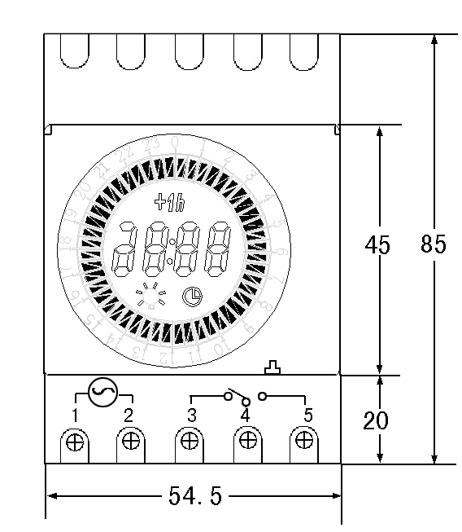 |  | 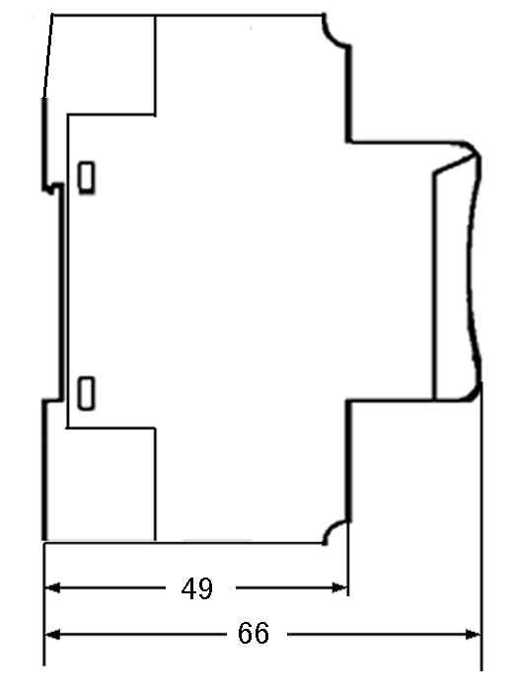 | 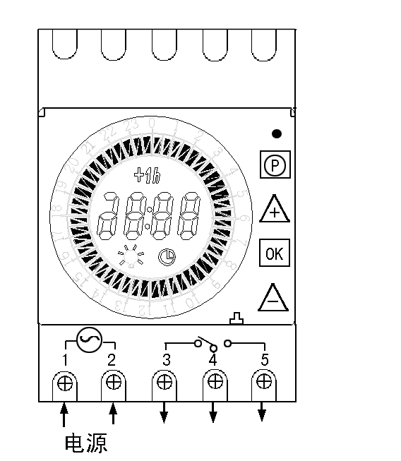

■ OPERATING INSTRUCTION:
1. If the timer switch is used for the first time or unused for long time, and it dose not displays,please input AC and let battery recharge .After then press reset key in the small hole which is located in the right-up corner of the panel.

2. Programming :
Step | Key | Programming
1 | Press P key | Begin Setting
2* | Press + or - key | Select on-time
3 | Press ok key | Set on-time and Press ok to confirm(If you want to add next 15minutes to on-time,you need to press this key again)
4 | Repeat 2-3 | Setting 2-48 on/off-time
5 | Press P key | End
3. CLOCK CALIBRATE
(1) Press “P” key for 2 seconds and the hour bit should be glinting.
- Press “+” key or” - ” key to set the hour of the real time
- Press ok key again and the minute bit should be glinting.
- Press “+” key or” - ” key to set the minitue of the real time
4.AMEND THE ON/OFF TIME
Step | Key | Programming
1 | Press P key | Begin Setting
2* | Press + or - key | Select the on-time which will be cancled
3 | Press ok key | Cancle the on-time,one time for 15minutes,and the key can press continuely.
4 | Press P key | End

5. If you want to use time switch ON or OFF at random,Please Press “ ok ”key to display “ON” or “OFF”.
6.Setting daylight saving time
Press “P” key and “+ ” key together, the real time can be added 1 hour.
■NOTE:
1.PLEASE USE IT IN THE CONDITION OF RATING VOLTAGE, REGULAR TEMPERATURE AND HUMIDITY, AND STOR IT IN REGULAR TEMPERATURE AND HUMIDITY.
2.PLESE DO NOT USE IT IN THE ENVIROMENT OF MUCH DUST,ERODED GAS, SOLARIZATED BY SUNLIGHTE DIRECTELY,OR DRENCHED BY RAIN.

